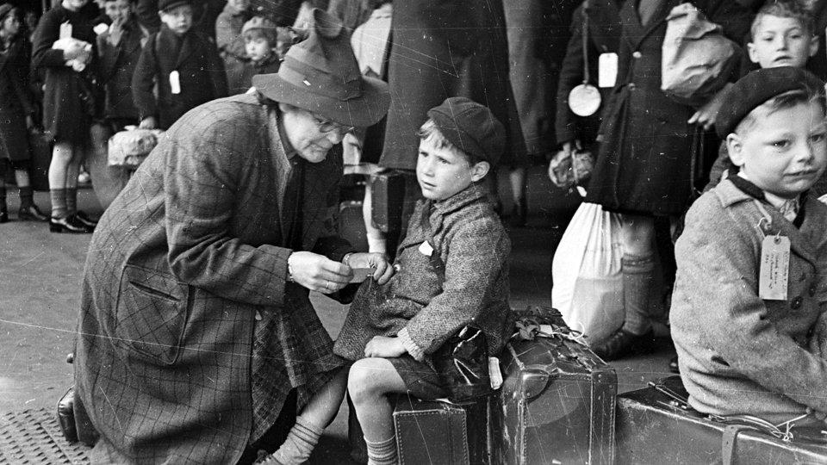
Welcome to Year 6 at Dinglewell Junior School.
Year 6 Newsletter 2025
Autumn Terms 1 and 2
Our topic this term is ‘Evacuees and Me’ which has a history focus on World War II from a child’s perspective.
Mathematics Topics include: Mental maths skills, Place Value, 4 rules, Fractions, Decimals and Percentages, Problem Solving and Shape.
English Topics include: Poetry, Narrative writing, Non-Chronological Writing, Diary writing, Newspaper reports, Instructions and Explanations.
Science Evolution and Inheritance.
History Finding out about what life was like for children during World War II. We will hold a WW2 experience day – date to follow.
Geography How global conflict affects the lives of children. Location of countries involved in World War II, grid references, how and why countries trade natural resources.
PE and Games Football, tag rugby and Gymnastics.
Music Rhythmic Devices and Structure, WW II music, Christmas carols/songs.
Art Drawing. Textiles and Collage.
DT Textiles – Christmas Decorations.
Computing Internet Safety, Networks and Understanding Binary.
PSHE Being Me and Celebrating Difference.
RE Why the Torah is so important to Jewish people, Why do Christians believe that Jesus was the Messiah?
French World War ll

Grammar Test for secondary schools
The grammar test will take place on Saturday 13th September. Homework will not be set until after this date.
Maths homework is set on a Monday and is due in each Thursday using the MyMaths. Please find your child’s login details in the back of their homework diary which is the same as last year. Children need to regularly practise their times tables and be familiar with ALL times tables. If your child loses their log in, please email year6@dinglewell-jun.gloucs.sch.uk and it will be emailed to you.

Reading Children are expected to read at home at least 3 times a week to an adult, which can be recorded in your child’s Homework Diary. The importance of reading is fundamental to your child’s progress and we follow the VIPERS model when asking pupils question about their given text, if you could do the same at home please.
For guided reading, we have chosen a new text called ‘When The Sky Falls’ by Phil Earle as our Autumn Term book. Whilst these books will remain in school, we hope that your child will enjoy talking to you about the text. Additionally, www.thereaderteacher.com/year6 has recommendations for reading books.
PE and Games Kit P.E kits will be required on a Tuesday and Thursday for all classes. Please ensure that your child wears appropriate shoes and clothing to school on these days, i.e. house colour T-shirts and dark shorts / tracksuit bottoms. No jewellery/watches are to be worn to school and long hair must be tied back. If your child has recently had their ears pierced, please can you provide them with micropore tape.
Fidget Tools
The SEND department will provide fidget tools for children who require them.
Mobile Phones
If your child brings a mobile phone to school, they are expected to turn it off at the school gates. Phones will be collected by staff and kept secure throughout the day. Please ensure that if your child uses social media, their accounts are checked regularly.
Spelling
We are following a new scheme called CUSP (Curriculum with Unity Schools Partnership) for spellings this year. The children will work on spellings during the week in class. Therefore, we won’t be sending home lists which will be tested each Friday. Children on the Special Needs register will work on their spellings during these sessions.
Communication
We do hope that your child enjoys their first term in Year 6. Should you have any you wish to raise, then please do not hesitate to contact any of the Year 6 teachers via the school office or email Mr Jones at year6@dinglewell-jun.gloucs.sch.uk Please remember to treat all staff respectfully when communicating via email or verbally.
Mr Jones (6J) Mrs Short and Mrs Benfield (6SB) Mrs Colloby (6C)

