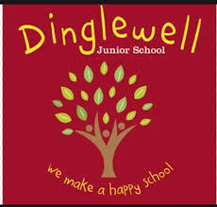Dear Parents/Carers,

On Monday 30th October, year 6 pupils will experience a WW2 day.

During the day, children will learn WW2 songs; eat traditional rationed recipes whilst celebrating VE day; learn and rehearse 1940s dances and discover artefacts while completing a WW2 quiz. **If your child has any dietary requirements/allergies, please can you inform their class teacher before the day.**

Children are invited to wear costumes as an evacuee or land army girl – pictures for inspiration are below. If however your child would prefer not to, please can they arrive wearing school uniform. Your child may also want to make a gas mask box at home. An evacuee tag is attached at the bottom of this letter.

Staff will take photos of the day and they will appear on the year 6 blog.

Kind regards,

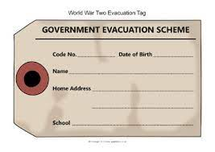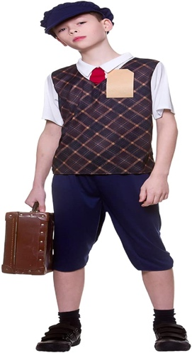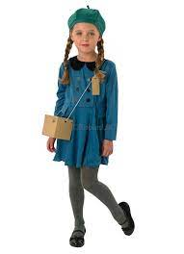Mr B. Jones