Dear Parents/Carers,

On Monday 16th October, year 6 pupils will experience a WW2 day.

During the day, children will learn WW2 songs, create a Dig for Victory recipe, design and make air-raid shelters and discover artefacts while completing a WW2 quiz.

Children are invited to wear costumes as an evacuee or land army girl – pictures for inspiration are below. If however your child would prefer not to, please can they arrive wearing school uniform.

Children also have the option to create a gas mask box as their homework for next week which they can wear alongside their costume on the day. Attached is an evacuee label which can be cut out, filled in and attached to their box.

We hope your child enjoys the day, staff will take photos and put them on the school website.

Kind regards,

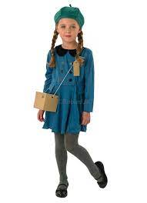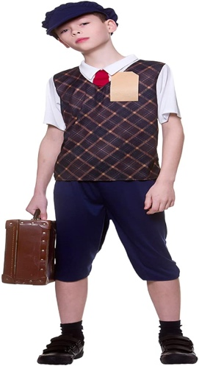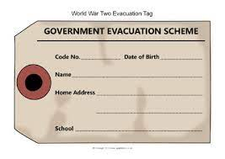Mr B. Jones