BOYS CLOTHING
Cap, Flat cap, Balaclava and woollen scarf.
White, Grey or Checked Pattern Shirt.
Short Trousers (boys didn’t wear long trousers
until they were teenagers!)
Jacket or Blazer
Cardigan or waistcoat (Wool) or a
sleeveless jumper.
Grey Socks
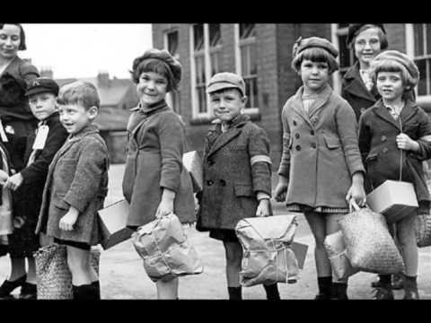
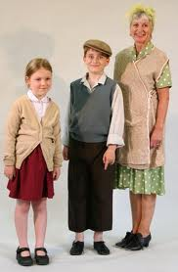
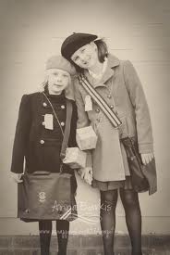
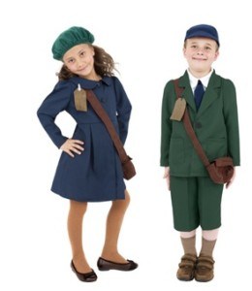
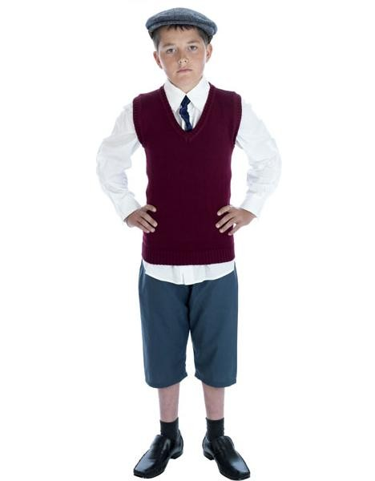
Plimsolls or lace up leather shoes.

GIRLS CLOTHING
Woollen coat, jacket or blazer
Straw, felt or knitted hat and scarf
Cotton or woollen dress
(Girls did not wear trousers)
Woollen skirt and Cotton blouse.
Woollen cardigan or sleeveless jumper
Long or short sleeved jumper.
Ankle socks, grey or white
Plimsolls, leather lace up shoes or sandals

MAKING A GAS MASK BOX
If your child wishes to bring in a gas mask box they will need a small square/oblong cardboard box. Shoe shops are normally quite happy to let people have old shoe boxes. (Small children’s shoe boxes are ideal). Make a hole either end of the short sides of the box. Cut a length of good quality string, long enough for your gasmask box to go over your shoulders, so the box can hang at your side. Thread the string through the holes in either end of your box and secure with good knots and sticky tape. Stick your respirator instructions inside the lid. Put the lid on the box and put over your shoulders. The children may bring one favourite “old fashioned” toy each…. a teddy, dolly or small toy car.

