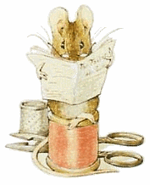
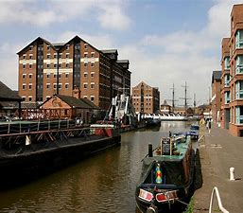
Year 3 Newsletter 2025
Summer Terms 5 and 6
Consider Yourself… Lucky!
Subject Overview
Our topic this term is “Consider Yourself… Lucky!” which concentrates on what life was like for children during Queen Victoria’s reign.
Mathematics Topics include: capacity, money and time.
English Topics include: Beatrix Potter, poetry, Dream Jars and the BFG, among others.
History Victorian history with a focus on children’s life.
Science Forces and Magnets
PE and Games Swimming, Gymnastics and Athletics
Music Pitch, pentatonic scale and performance
Art Tone, shadow and William Morris.
Computing Presenting, Branching databases and Simulations
RW Good Friday and Pentecost.
French Little Red Riding Hood
DT Levers and linkages
PSHE Relationships and Changing Me.
Home Learning
- Maths homework will be set on MyMaths each Monday from next week. Also please use Numbots and TTRockstars – logins should be glued in the Reading Records, please contact us if you need a reminder.
- The first spelling test will be on Friday 2nd May.
- We would love children to read at home as frequently as possible. Please jot a signature next to your child’s comment, target at least three a week; books will continue to be changed on Mondays, Wednesdays and Fridays.
- Please feel free to use the Reading Record as a means of communicating with teachers or through the year3@dinglewell-jun.gloucs.sch.uk email address for any non-urgent requests / information.
PE and Games
Indoor PE will continue to be on a Friday and swimming will be on Tuesdays for all three classes.
Please continue to come to school dressed in sports kit with house coloured t-shirt and suitable footwear on PE days.
Year 3 Team
Miss Brooke Mrs Hazell Mrs Cave
3B (Whittington) 3H (Potter) 3C (Jenner)
Teaching Assistants: Ms Ederveen, Mrs Sinclair, Mrs Moorhouse
PPA cover: Ms Hayward

