cid:image003.png@01D5B0EC.40920720

EXTRA Early Help Newsletter Gloucester: March 2020

Hello All,

This EXTRA newsletter is specifically designed for our Children and Families within Gloucester, so they know who they can turn to for advice and guidance. Please feel free to disseminate this to all families and children.

Our NHS colleagues are working tirelessly on helping to reduce the risk to our most vulnerable people and advice on anything relating to the illness will be found on <https://www.nhs.uk/conditions/coronavirus-covid-19/>

Kindest regards

Early Help Coordinators Gloucester

The Family Information Service directory [www.glosfamiliesdirectory.org.uk](http://www.glosfamiliesdirectory.org.uk) holds a wide range of information advice, and signposting to support families, children and young people from 0 - 19 years of age (25 for young people with additional needs). This includes information on finding and choosing childcare, such as local day nurseries, playgroups, childminders, children's centres, out of school clubs and holiday playschemes.

The directory also provide information on:

* Family Support
* 2, 3 & 4 year old funding towards childcare
* 30 hours funding for working parents and some foster carers
* Referrals for parenting programmes including Triple P, Solihull, Webster Stratton and You & Me, Mum
* The Key Disability Register
* Tax Credits, Benefits.

Parent/Carers can also view/download from the Family Information Service page useful resources to support family life, including a Parent's Guide to mobile phone and internet safety, being left Home Alone to name just a few.

Practitioners will also be able to access useful information including training and referral forms from within the relevant sections.

Church services will continue for as long as possible - see our website [www.stpaulstephenglos.org.uk](http://www.stpaulstephenglos.org.uk) .

The church will be open each day for a place and space to pray and think.

Food parcels can be given - contact me on 01452 500537 or come to the church on a Tuesday or Thursday morning.

Telephone discussions - Rev Ruth Fitter on 01452 500537 or 07502 306083 or Rev Heather de Gruyther on 07464 816154.

**Kingfisher Church Tredworth**

[Info@kingfisher.org.uk](mailto:Info@kingfisher.org.uk)

Facebook page @kingfishertredworth

01452 304339 (leave a message if no reply with a contact number we can get back to you on)

At the moment none of our groups are running due to the Coronavirus but we are available for telephone support and for shopping needs if families are having to self-isolate!

Ollie Bennett

Pastor

Rachael Bennett (Children’s worker)

Bev Lloyd (Children’s worker)

[](https://thefriendshipcafe.com/)

Where is it? Chequers bridge Centre, Painswick Road

Contact Details: 01452 308127 – ask for Imran [imran@thefriendshipcafe.com](mailto:imran@thefriendshipcafe.com)

What can we offer? Possible emergency food parcels. For residents of Barton & Tredworth and our neighbours at City Farm and Friendship Café.

High vulnerability groups asked not come in but please call in and we can see if we can find someone to help/send food out.

GL Communities: your number one source for community development, advice and resources. We're dedicated to giving you the very best in help and information, with a focus on community development, well-being and a money advice service.

Founded in 2008 and receiving its charity status in 2010, GL Communities has come a long way from its humble beginnings. GLC was a merger of three of the most successful of the neighbourhood projects in Gloucester but is now able to offer services all over Gloucestershire.  We are thrilled to be able to turn our passion into work on the ground that creates change with local people.

Trinity Centre- 01452 505544

Advice Line – 01452 306581

Phoenix Centre – 01452 521557

This project work with residents of Matson, Robinswood, White City and Podsmead, Tuffley and Stonehouse areas.

[Together In MatsonTogether In Matson](https://togetherinmatson.co.uk/)

Together In Matson: Contact details:   01452 381070 Facebook              Redwell centre

Covering Matson & Robinswood Area

We will be cooking over the next few days to stock our freezers with containers of food that can be warmed in the microwave. If anyone elderly is isolated and needs food, we can deliver. Unless anyone asks for any specific help this is what we will be supporting.



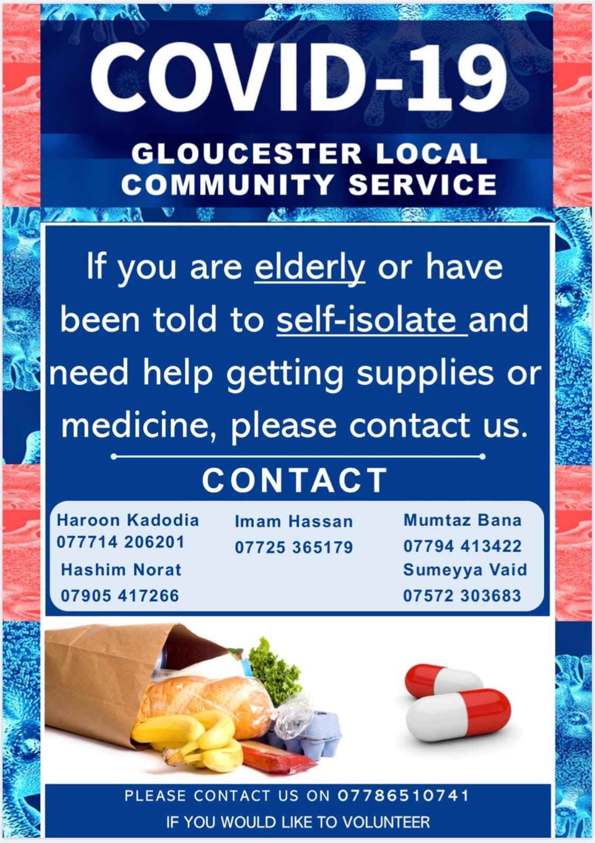

The National Trust are being incredibly generous, look after your well-being:

<https://www.nationaltrust.org.uk/>

‘At this time of everything closing

the National Trust have agreed to remove all pay barriers from National Trust parks and Gardens. This is in response to do what we can for everyone at this time to support social distancing and the need to be outside in nature for our own mental wellbeing. It will mean that all the grounds behind pay barriers will now be open for everyone. In addition all car parking chargers will be removed. You can enjoy the open space and keep your social distance as per the government advice.

We will however be closing all cafes, houses, retail, and cancelling events. So take a flask and a sandwich.

There is no commercial drive behind this, it will cost the charity a significant loss in income - but we acknowledge mental health and wellbeing at this time is the priority.

Also, the National Parks are free and always open.

Stay at home as much as you can, but when you need it - nature is there for you and free’.

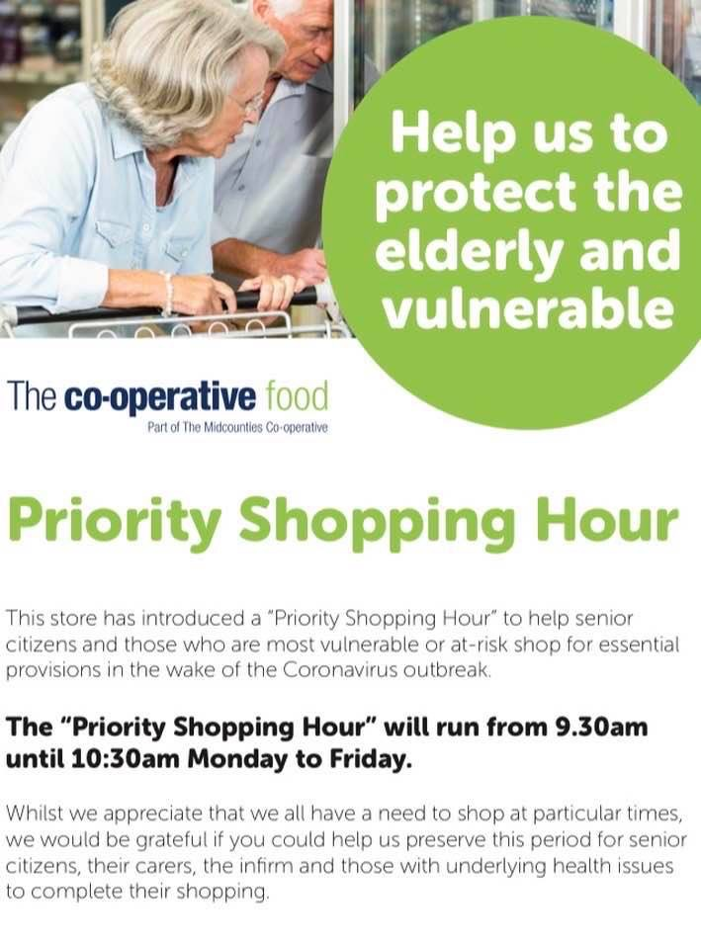

[](http://www.glosyoungcarers.org.uk/)

Our assessment workers are working remotely taking referrals and conducting assessments by telephone or video whatsapp or skype. 01452 733060

We will not be undertaking any groups or activities at this time.

We are proactively posting ideas to help young carers stay connected on our facebook page and shortly on the websi

<https://www.facebook.com/GloucestershireYoungCarers/>

te [www.glosyoungcarers.org.uk](http://www.glosyoungcarers.org.uk) ; @GloucestershireYoungCarers

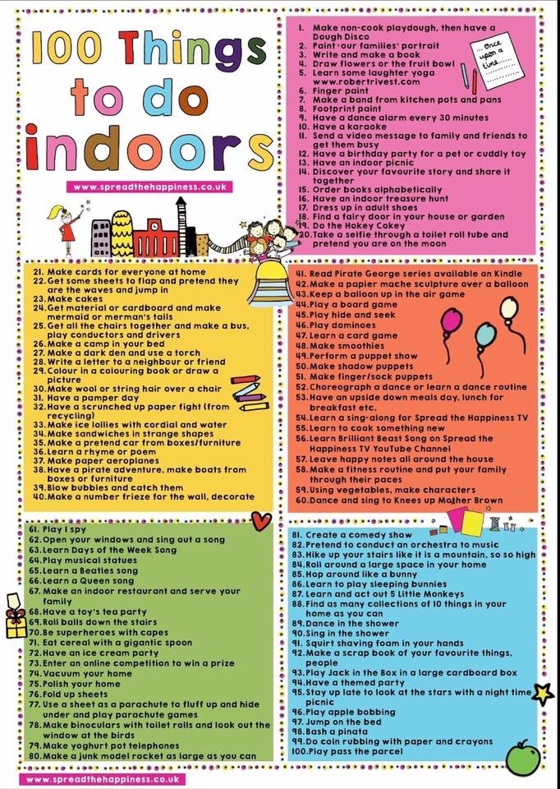

Apps to help with home schooling:

<https://kidsactivitiesblog.com/135609/list-of-education-companies-offering-free-subscriptions/>

<https://www.twinkl.co.uk/search?term=school%20closure>

[](https://www.google.co.uk/imgres?imgurl=https://sd.keepcalms.com/i/keep-calm-and-look-out-for-your-neighbour.png&imgrefurl=https://keepcalms.com/p/keep-calm-and-look-out-for-your-neighbour/&tbnid=J9n4rRIqWBeUSM&vet=12ahUKEwic1Ima_57oAhUK_BQKHcOzCtEQMyg3egQIARB4..i&docid=7Puw30x20dHAgM&w=600&h=700&itg=1&q=looking%20out%20for%20neighbours&ved=2ahUKEwic1Ima_57oAhUK_BQKHcOzCtEQMyg3egQIARB4)

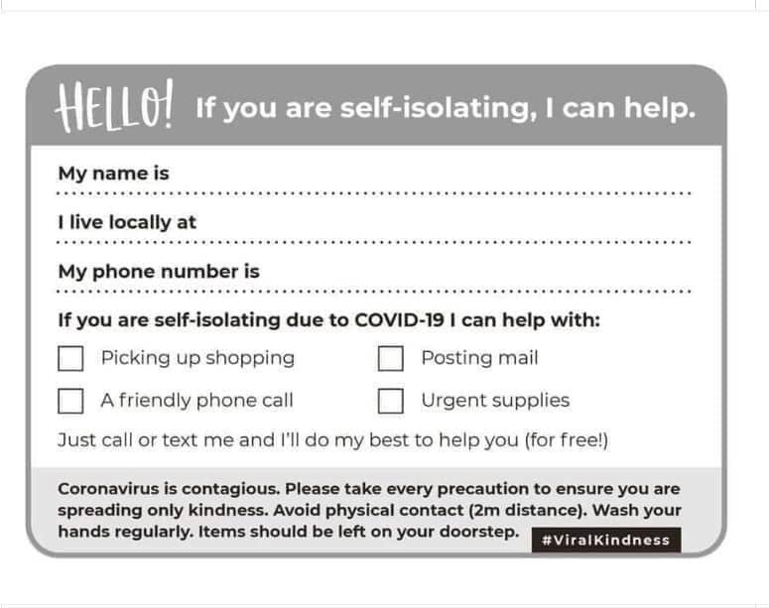

[](https://www.google.co.uk/url?sa=i&url=https://101quotesabout.blogspot.com/2019/05/be-kind-quotes-in-world-where-you-can-anything.html&psig=AOvVaw3hhMj1WBL7YP3V0RsGKBJR&ust=1584448214162000&source=images&cd=vfe&ved=0CAIQjRxqFwoTCIDyydz_nugCFQAAAAAdAAAAABAD)