YEAR 5 Maya Magic Homework

Reading, writing and speaking | Who was the most famous Mayan King or Queen? Describe them.   | Pretend you are an explorer who has just discovered a new tomb in the amazon. Write a letter home to your family about the discovery.  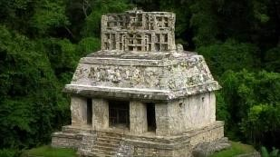 | Write a newspaper article announcing that a new Mayan pyramid or tomb has  been discovered. | Invent a new chocolate bar – design an advert for it - make sure you include lots of persuasive vocabulary. | Write a story set in the time of the Ancient Maya.  Include:  - A beginning  - A build-up  - A problem  - A solution  - An ending
Maths and  Science | Science: Create a model of the Solar System. This can be 2D or 3D using materials of your choice (card, playdough, cake?)  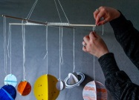   | Science: Research two different things that were invented by the Maya. Create a fact-file about  them.  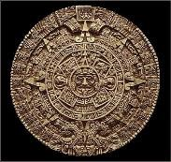 | Maths: The Mayans used a base 20 number system. Can you research and write the numbers 1-  20 in Mayan numbers? | 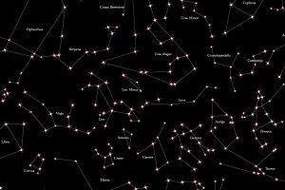  Science: The Maya studied the stars. Google and download “Stellarium” and use it to research 3 different constellations. | Science: The Mayans discovered chocolate.  Design and conduct an experiment melting different types of chocolate/chocolate bars. Display your results effectively.
Art and design technology | 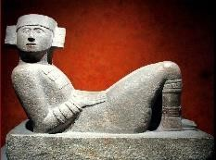  Sketch a Mayan artefact. | Paint a picture of a Mayan  God.  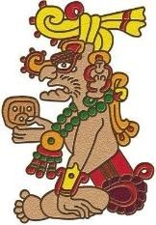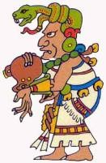 | Draw 3 Mayan hieroglyphs and write  down what they mean.  Challenge: can you write a Mayan sentence (worth 4 points). | Make a moving Mayan calendar.  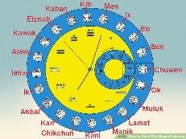 | Make a Mayan pyramid.  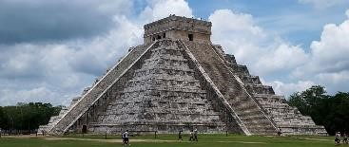
Active and hands-on | Imagine you had a time machine. What questions would you ask a Mayan?  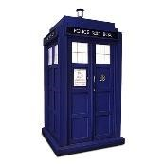 | 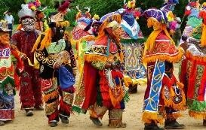  With a friend, choreograph a Mayan dance. | The Maya farmed maize… Cook something with sweetcorn in it!  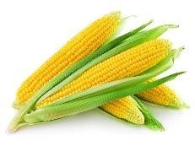 | The Maya discovered chocolate. Cook something with chocolate in it!   | Make a Mayan temple carving.  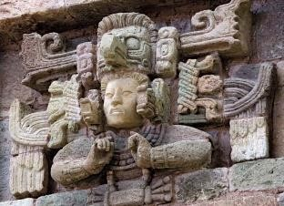
Other ideas | Listen to some Ancient Mayan music on YouTube.  Note down the different instruments you can hear. | Make a Mayan hot chocolate for your family to share.   | Pretend you are an Ancient Maya expert. Ask someone to quiz you to test  your knowledge . | With a group of friends, play your own version of the Mayan ballgame.  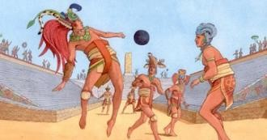 | With a partner, research and make a PowerPoint about an area of Mayan life you are interested in:  - Food  - School  - Music  - Religion
Independent work | Read a fact book or use the internet to research the Maya - write down 10 interesting facts. | https://www.bbc.co.uk/educ ation/topics/zq6svcw/resou rces/1  Watch and take notes on the BBC schools Mayan videos. | Make a Mayan board game.  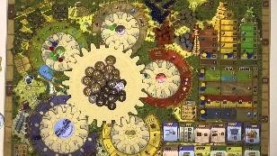 | Make a Mayan costume or headdress. | Make a model of a Mayan house.  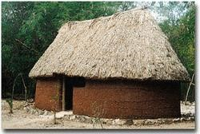

Homework can be uploaded to TEAMS through assignments or brought into school. Each week the assignment will show on TEAMS so that new work can be uploaded. Try to complete at least eight tasks by Easter. Don’t forget to add any house points that you earn on class dojo. Your TEAMS log-in should be in your reading diary.

Thank you.
Year 5 Team

