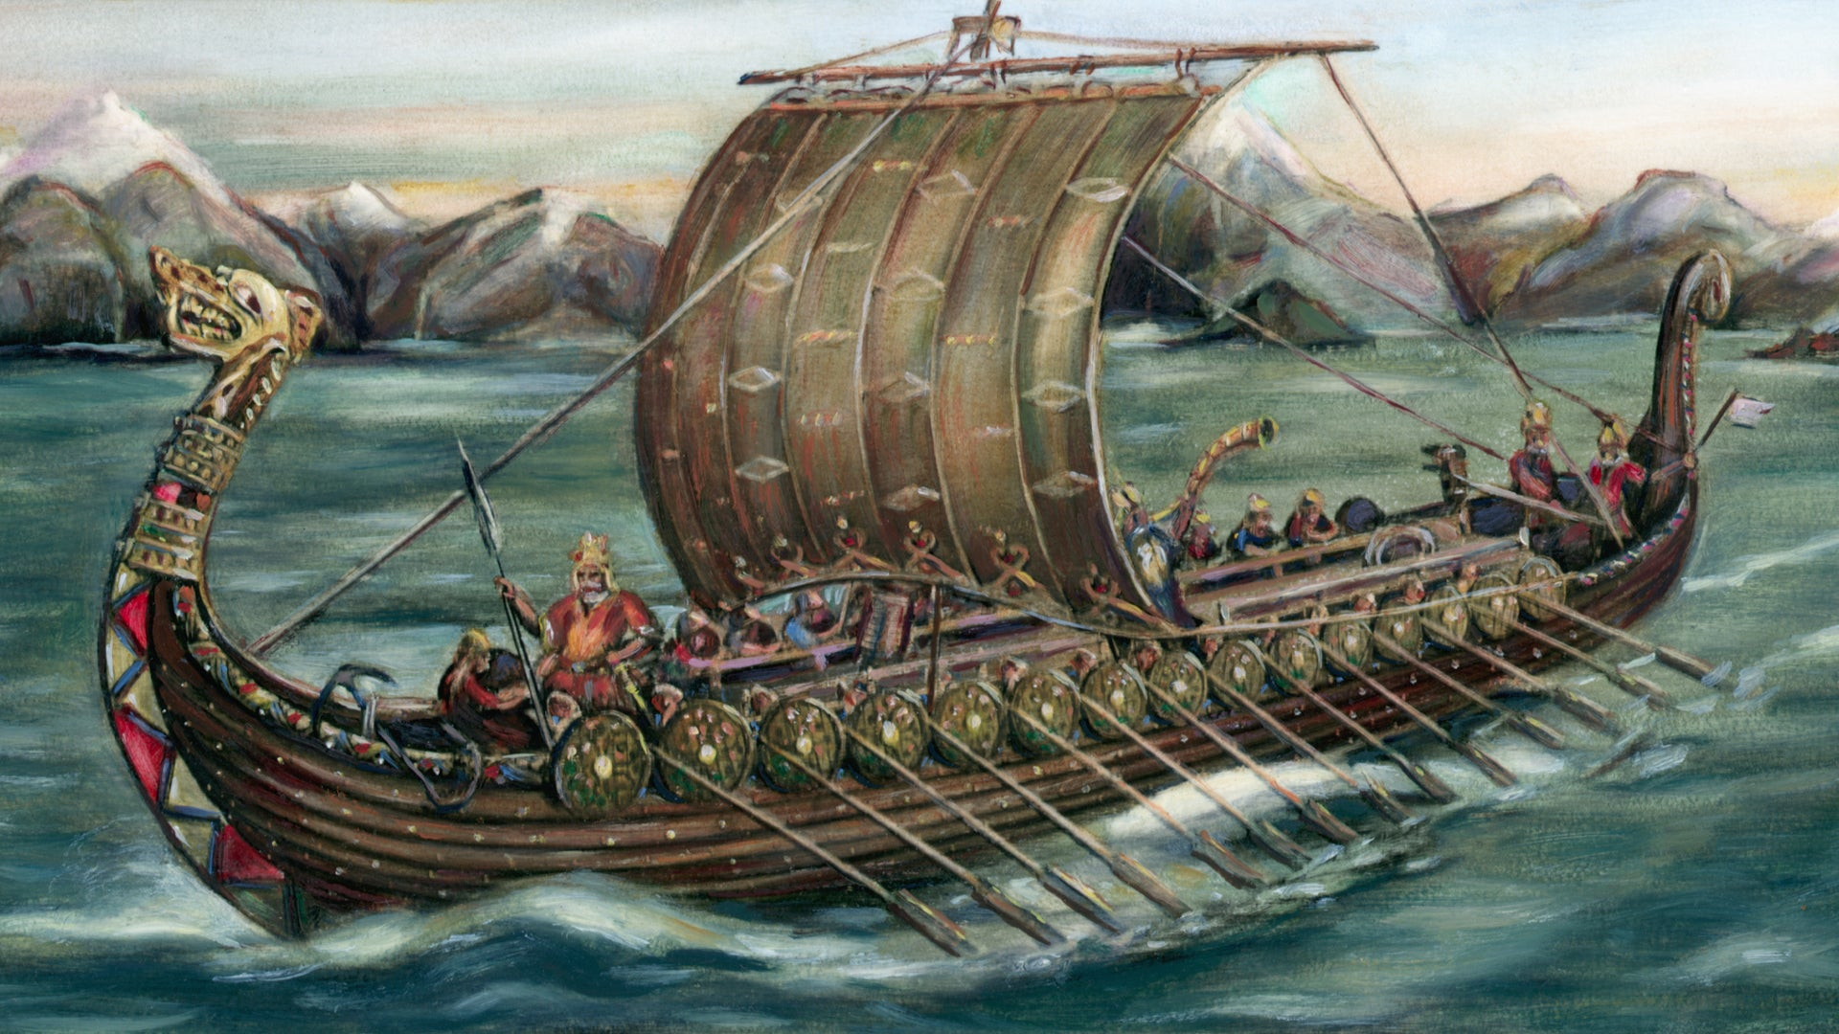
YEAR 5 NEWSLETTER

TERM 3 & 4 SPRING 2024

VOYAGES OF DISCOVERY

Subject Overview

Our topic this term is “Voyages of Discovery” which has a focus on the Vikings, the novel “A Kind of Spark” by Elle McNicoll and the topics of “Earth and Space” and “Forces” in science.

Mathematics | Topics include: mental arithmetic skills, place value, multiplication and division, fractions, measure, shape and data handling.
English | Poetry – linked to the Magic Box.  Narrative writing and instructions using the short film “La Luna”.  Biographies using the book “Hidden Figures”.  Writing linked to our whole class reading text “A Kind of Spark.”
History | The Vikings
Science | Earth and Space, Forces
DT | Designing and making moon buggies
PE | Dance
Games | Netball and Tennis
Music | Music and Words (Sparkyard scheme)
Art | Art work linked to the short film “La Luna.”
Computing | Coding, Modelling and Word Processing
PSHE | Dreams and Goals, Healthy Me
RE | What does it mean to be a Muslim in Britain today?  What do Christians believe Jesus did to ‘save’ people?
French | Weather and At the Cafe

Homework

- 'Home Learning Activities' related to our topic will be given out next week which will cover up to Easter. We would like work uploaded to TEAMS but please send in if this is not possible or your child would particularly like to share something with the class.
- Maths homework is set on a Monday and is due in by the following Thursday. It is set on the internet using the My Maths website. If your child loses their login during the course of the year – please contact us for a new one.
- Please encourage your child to read at home as frequently as possible. It would be helpful if they could also talk about the book with an adult and a comment made in their Reading Record book.
- Please feel free to use the Reading Record as a means of communicating with the Class Teachers.
- The children need to learn their times tables, so practising at home will be valuable to them. TT Rockstars is a great way of doing this.

PE and Games

Indoor PE - Tuesday for all classes
Outdoor Games - 5H Wednesday and 5R/5SL Thursday

Children need to wear appropriate PE kit to school on their PE days; this should be house coloured t-shirts, school sweatshirts, black/navy jogging bottoms and trainers. No jewellery should be worn (please remove earrings for PE days, newly pierced ears must be taped). Long hair needs to be tied back please.

FOREST SCHOOL

Forest School sessions will begin on Tuesday 16th January. Please see the letter from
Mr Randell which gives details of what the children will need to wear and when their sessions are.

SPELLINGS

Termly spelling sheets will be stuck in your child’s reading record. The children will work on the spellings during the week in class and will be able to practise them at home. They will be tested on a Friday. If you have any questions regarding spelling, then please ask your class teacher.
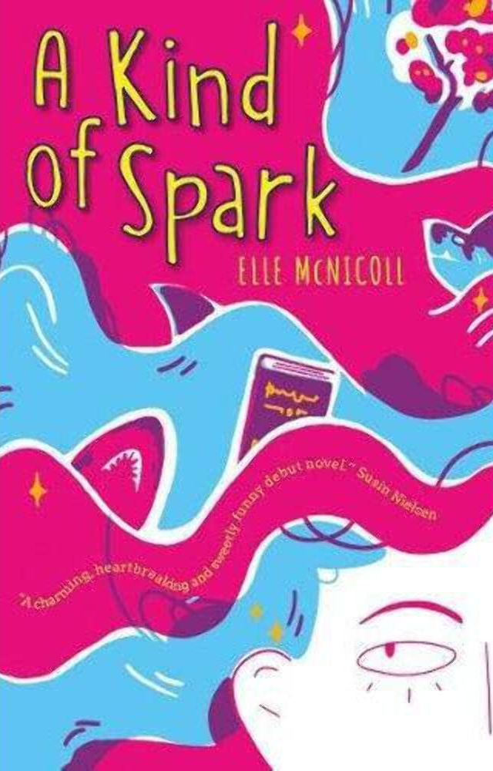
WHOLE CLASS READING

Our focus text is “A Kind of Spark” by Elle McNicoll. We will be providing copies in class for your child to share, however we are always happy for children to bring their own copy if they have the book already.

Year Five Team

Year Group Leader: Mrs V Halford
Class 5H | Class 5SL | Class 5R
Mrs Halford  Miss Brogan (Fridays) | Mrs Stanley (Mon-Wed)  Mrs Lyons (Thurs-Fri) | Mr Randell  Mrs Colloby (Fridays)
Teaching Assistants: Mrs Gough, Miss Ederveen, Mrs Hipkiss, Miss Barltrop, Mrs Moorehouse and Mrs Wyatt.

