
YEAR 5 NEWSLETTER

TERM 3 & 4 SPRING 2023

MAYA MAGIC

Subject Overview

Our topic this term is “Maya Magic” which has a focus on the history of the Ancient Maya, the novel Cogheart by Peter Bunzl and “Earth and Space” and “Forces” in science.

Mathematics | Topics include: mental arithmetic skills, place value, multiplication and division, fractions, measure, shape and data handling.
English | Poetry – linked to our science space topic.  Narrative writing and instructions using the short film “La Luna”.  Biographies using the book “Hidden Figures”.  Newspaper reports linked to our novel Cogheart.
History | Who were the Ancient Maya?
Geography | Mountains
Science | Earth and Space, Forces
DT | Designing and making moon buggies
PE | Gymnastics, Dance and Fitness
Games | Netball and Tennis
Music | Music appreciation linked to magical tunes, notation and composition linked to BBC Ten Pieces Earth.
Art | Art work linked to our novel Cogheart, the Maya and Space Art
Computing | Coding, Modelling and Word Processing
PSHE | Dreams and Goals, Healthy Me
RE | What does it mean to be a Muslim in Britain today?  What do Christians believe Jesus did to ‘save’ people?
French | Weather and At the Cafe

Homework

- 'Home Learning Activities' related to our topic will be given out next week which will cover up to Easter. The homework tasks are not mandatory: you and your child might choose which tasks you think your child would most benefit from completing. Please, by all means make them mandatory for your child. We would like work uploaded to TEAMS but please send in if this is not possible or your child would particularly like to share something with the class.
- Maths homework is set on a Monday and is due in by the following Thursday. It is set on the internet using the My Maths website. If your child loses their login during the course of the year – please contact us for a new one.
- Please encourage your child to read at home as frequently as possible. It would be helpful if they could also talk about the book with an adult and a comment made in their Reading Record book.
- Please feel free to use the Reading Record as a means of communicating with the Class Teachers.
- The children need to learn their times tables, so practising at home will be valuable to them. TT Rockstars is a great way of doing this.

PE and Games

Indoor PE - 5CL Tuesday, 5H and 5R Thursday
Outdoor Games - 5H and 5R Monday, 5CL – Friday

Children need to wear appropriate PE kit to school on their PE days; this should be house coloured t-shirts, school sweatshirts, black/navy jogging bottoms and trainers. No jewellery should be worn (please remove earrings for PE days, newly pierced ears must be taped). Long hair needs to be tied back please.

Forest School

Children have received a separate letter to let them know when their Forest School sessions are this term. The dates for this term’s sessions are below:

Class 5R: 10.1.23, 31.1.23 Class 5H: 17.1.23, 7.2.23 Class 5CL: 24.1.23, 14.2.23

SPELLINGS

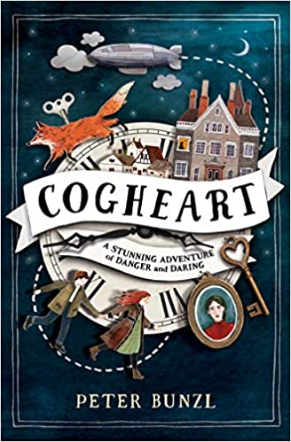
Termly spelling sheets will be stuck in your child’s reading record. The children will work on the spellings during the week in class and will be able to practise them at home. They will be tested on a Friday. If you have any questions regarding spelling, then please ask your class teacher.

WHOLE CLASS READING

Our focus text is “Cogheart” by Peter Bunzl. We will be providing copies in class for your child to share, however we are always happy for children to bring their own copy if they have the book already.

Year Five Team

Year Group Leader: Mrs V Halford

Class 5H Class 5CL Class 5R
Mrs V Halford Mrs M Colloby and Mrs L Lyons Mr S Randell
Miss Brogan (Fridays)
Jenner house (yellow) Whittington house (green) Potter house (red)
Teaching Assistants: Mrs Kamath, Miss Ederveen and Ms Barrett.

