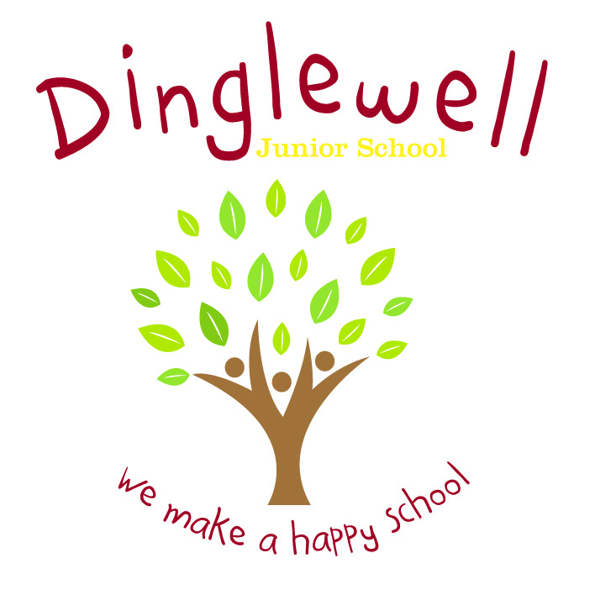Dinglewell Junior School

Pupil Premium Strategy for the academic year 2019-2021

At Dinglewell Junior School we are passionate about enabling all our children to have the best chances in life. Our aim is to ensure that all children fulfil their potential and make outstanding progress through high aspiration for all; rich and tailored experiences within our inspiring curriculum; careful and impactful use funding to maximise learning of both knowledge and skills; and a robust and reflective focus on the impact of the work we do.

|  |  |  |  |  |
| --- | --- | --- | --- | --- |
| **Summary information** | | | | |
| **CURRENT PUPIL INFORMATION 2020-2021** | | | | |
| Total number of pupils on role: | 360 | Total pupil premium budget: | £51,316 | |
| Number of pupils eligible for pupil premium: | 47 (13%) |  | | |
| **Assessment KS2 2019**  **(KS2 TA 2020 due to no SATs Tests)** | **Pupils eligible for pupil premium** | **School average** | | **National average** |
| % achieving expected standard or above in reading, writing and maths | 53% (80%) | 80% (69%) | | 65% |
| % making expected progress in reading | 59% (80%) | 86% (86%) | | 73% |
| % making expected progress in writing | 71% (80%) | 87% (83%) | | 78% |
| % making expected progress in maths | 76% (80%) | 93% (90%) | | 79% |

|  |  |
| --- | --- |
| **Summary of focussed intentions leading to improved outcomes FOR 2019-2021 ACADEMIC YEARs** | |
| Desired Outcomes | Success Criteria |
| 1. To close/narrow the performance gap in reading, writing, maths between disadvantaged children and their peers. To accelerate the progress of those at risk of under achievement through targeted intervention |  |
| 2. Curriculum structure will be rich, engaging and sequential in all subjects (summer 2021) |  |
| 3: To enhance pastoral and SEN support in order to improve emotional wellbeing, barriers to learning and attendance of disadvantaged children |  |
| 4. To raise self esteem and attitude towards learning by improving resilience and perseverance |  |
| 5. Disadvantaged children will have the same enriching educational experiences as their peers |  |

|  |  |  |  |  |  |
| --- | --- | --- | --- | --- | --- |
| **Total pupil premium allocation for 2019-2021** | | | | | |
| Objective 1: To close/narrow the performance gap in reading, writing, maths between disadvantaged children and their peers. To accelerate the progress of those at risk of under achievement through targeted intervention | | | | | |
| **Intent** | **Action** | **Implementation** | **Staff Lead** | **Cost/resource implications** | **iMPACT MEASURE** |
| Progress in reading, writing and maths is raised for PP children | DHT covered teaching time so that booster groups can be run. | Pupil progress meetings  Use of assessment data on insight | DHT | £4500 | Standards and progress raised for PP children |
| Progress in reading, writing and maths is raised for PP children | Extra teacher working in Year 3 for catch up | Pupil progress meetings  Use of assessment data on insight | YGL | £15000 | Standards and progress raised for PP children |
| Progress in writing is raised for PP children | TA employed extra hours during the afternoon to work with Year 5 children | SLT and YGL monitoring which children will benefit from extra writing practice. Planning and work will be provided | SLT &YGL | £5940 | Standards and progress raised for PP children |
| Standards and progress in Maths is raised for PP children | Employment of one-to-one tuition for maths | Maths assessments  Assessment tracking  Raised confidence in the children | DHT | £2000 | Standards and progress raised for PP children |
| PP children have access to extra resources | Study books to be bought for all PP children in Year 6 | Information evening with parents led by DHT  Study books distributed | TN | £250 | Children have resources and opportunities to help revise for tests.  Excellent progress made |

|  |  |  |  |  |  |
| --- | --- | --- | --- | --- | --- |
| **Total pupil premium allocation for 2019-2021** | | | | | |
| Objective 2: Curriculum structure will be rich, creative and sequential in all subjects so that children are engaged and make excellent progress (summer 2021) | | | | | |
| **Intent** | **Action** | **Implementation** | **Staff Lead** | **Cost/resource implications** | **iMPACT MEASURE** |
| Rich and exciting curriculum accessed by all to enhance excellent progress | Curriculum leads training  Network meetings for English, maths, science  Staff meeting planning time for foundations  Intent statements for all curriculum areas | GCC Network Meetings  GSP Meetings  Staff meetings for planning foundation areas  Collaboration with outside professionals | Networks  Time out of class for subject leaders | Time allocated for staff meetings | Coherent planning to enable children to know more, remember more and do more.  Curriculum intent implemented effectively for all areas  Impact is evident through pupil voice, results and book looks  Teachers are knowledgeable about their curriculum area |
|  |  |  |  |  |  |

|  |  |  |  |  |  |
| --- | --- | --- | --- | --- | --- |
| **Total pupil premium allocation for 2019-2021** | | | | | |
| Objective 3: To enhance pastoral and SEN support in order to improve emotional wellbeing, barriers to learning and attendance of disadvantaged children | | | | | |
| **Intent** | **Action** | **Implementation** | **Staff Lead** | **Cost/resource implications** | **iMPACT MEASURE** |
| Pastoral support for emotional wellbeing of disadvantaged children | Noted that a high percentage of PP children have emotional and social needs that create barriers to learning, so PIM now working full time in our school | PIM working alongside all children who require support to break down barriers to learning  Outside agencies identified for those children requiring more specialized support | PIM | £17000 | Children receive pastoral support required to enable them to break down barriers so that they can be in the right place to learn  Additional specialised support targeted at those who need it so they are emotionally ready to learn |
| Disadvantage children have opportunity for free milk every day | Provide milk daily | Milk for disadvantaged children ordered | HT HH | £580 | Nutritional drink to help growth – same experiences as all children |
| Increase SENDCo provision for SEN support | Increase SENDCo hours from 3 to 5 days per week through restructuring staffing  SEND actions to ensure EHCP provision is sufficient to meet needs and increased hours | JD to work 2 days SENDco alongside HP’s 3 days | HP JD |  | Provision for all SEND children  SEND children making good progress  Reviews completed on time  New role as SENDCo for JD |

|  |  |  |  |  |  |
| --- | --- | --- | --- | --- | --- |
| **Total pupil premium allocation for 2019-2021** | | | | | |
| 4. To raise self esteem and attitude towards learning by improving resilience and perseverance | | | | | |
| **Intent** | **Action** | **Implementation** | **Staff Lead** | **Cost/resource implications** | **iMPACT MEASURE** |
| Raise self esteem and children to have more positive attitude towards themselves, engaging in all areas of school life | Identify children with low self esteem  Employ Chance for Change to work weekly with these children  TAs to attend Jenny Mosley virtual training  Year 4 to complete PSHE ‘Make me a superhero’ | Children identified  Chance for Change to work one day a week with children identified  TAs engaging with children and identifying those with low self esteem and attitudes towards learning | PIM oversee | Chance for Change  £2400  TA training  Time out for course | Self esteem and attitude towards learning improved  Counseling to help children identify coping mechanisms and techniques to deal with situations |
| To improve resilience and perseverance | Opportunities given inside and outside of the classroom to encourage children to keep going and not give up at the first hurdle. This is woven through the curriculum but also opportunities not usually taken up by PP children | Opportunities to be woven into curriculum to encourage resilience and perseverance  Celebrate mistakes and encourage having another go  Tasks given to challenge | DHT HT | Staff Meeting time to check planning | Children ready to ‘have a go’ inside and outside the classroom.  Mistakes are celebrated rather than looked down upon by children |

|  |  |  |  |  |  |
| --- | --- | --- | --- | --- | --- |
| **Total pupil premium allocation for 2019-2021** | | | | | |
| Objective 5: Disadvantaged children will have the same enriching educational experiences as their peers | | | | | |
| **Intent** | **Action** | **Implementation** | **Staff Lead** | **Cost/resource implications** | **iMPACT MEASURE** |
| All children will have access to the same enriching experiences | Monitor participation in school trips and extra-curricular activities  Offer subsidy for Year 6 residential | Audit of clubs  Allocation of clubs overseen by JH  PP children informed of subsidy for Year 6 residential | HT JH  HT | £2400 | Trips and extra-curricular activities attended by children |