
Year 6 Newsletter 2025
Summer Terms 1 and 2
Our topic for this term is entitled ‘Make That Change’.
Mathematics We will be revising topics taught so far this year. Further number work and problem-solving following SATs.
English Topics include: Grammar revision, Persuasion, Poetry, Autobiographies and Scripts.
Science Classification. Circulatory System with healthy living and lifestyles curriculum links to PE and PSHE.
Geography Learning about improving or damaging the environment.
PE and Games Badminton, Tennis, Fitness and Athletics.
Music Celebrating songs. Recorder playing.
Art Sculpture.
ICT iMovies.
PSHE Relationships and Changing Me.
RE Why do some people believe in God and some people do not?
DT Dinglewell ‘Bake Off’.
French Language Angels scheme – ‘The Weekend’ and ‘Me in the World’.

Revision and Reading
In the lead up to SATs, if you have purchased any of the CGP revision books, please continue to work through them in addition to reading at least 3 x per week. Please use the VIPERS acronym when asking children about their reading book. Our class text this term is ‘Final Year’ by Matt Goodfellow.

PE and Games Kit
Please could you ensure that your child wears appropriate shoes and clothing to school on the days that they have PE, i.e. house colour T-shirts and dark shorts / tracksuit bottoms. No jewellery or watches should be worn to school on these days and long hair must be tied back.
Indoor PE – Tuesday
Outdoor Games - 6J Monday and 6PB and 6R Wednesday.
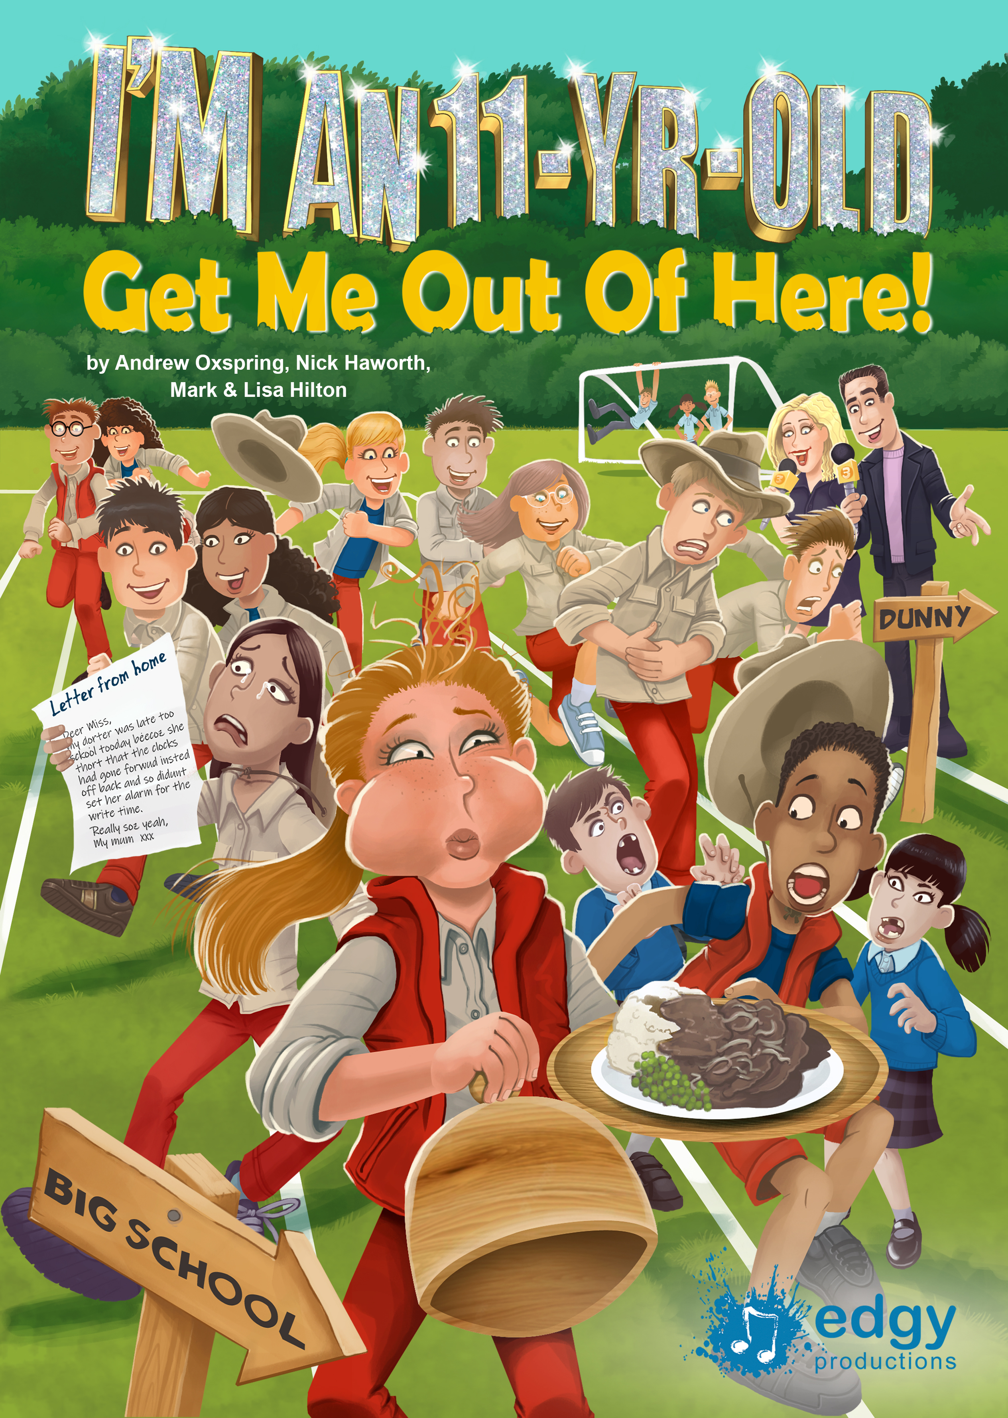
Leavers’ Production
This year we will be rehearsing for our leavers’ performance following SATS. If your child is given a talking role, please can they rehearse their lines at home while we also rehearse in school. Songs are also on the Year 6 blog to learn. The performance will be on Wednesday 16th July at 1.30 pm. More details will follow, but there will be a maximum of 2 tickets per pupil.

SRE
Throughout the week of 23rd June, Year 6 will have their SRE unit. On Monday 16th June at 3.30-4pm, Mr Jones will hold a meeting for parents to come and see what materials the children will use should you wish to attend. Please note that younger children will not be able to attend the meeting due to the age-appropriate content.

Transition
We appreciate that this term can potentially be an anxious time for your child in regards to secondary school transitions. Please be assured that we will focus on transition tips during CPSHE. The children will also have transition days (invitations from secondary schools) and heads of Year 7 will come in to meet the children where they will receive a handover from class teachers. Please can you inform the school office if you need time out to try on secondary school uniforms.

Contact
Should you wish to discuss anything with your child’s class teacher, please contact the school office or email Mr Jones at year6@dinglewell-jun.gloucs.sch.uk

Miss Richardson Mrs Colloby and Mrs Benfield Mr Jones

