**Subject: 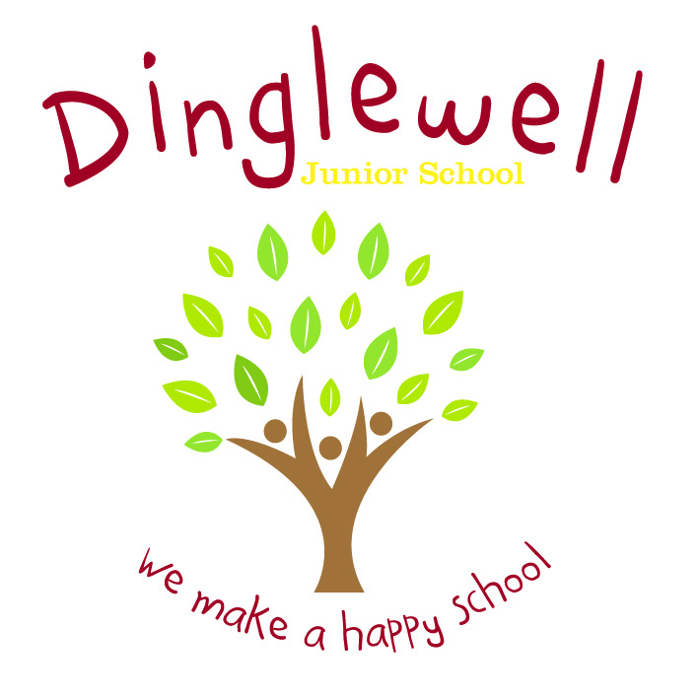Reading**

**Implement: (How are we going to do it)**

* Teachers plan and deliver both whole class and small group Guided Reading lessons, using a wide range of different texts.
* Children provided with books that match and support their reading ability and class libraries to be stocked with texts to inspire those pupils’ ‘free reading.’
* Pupils to record home reading in their ‘Reading Record and Homework Diary,’ understanding the expectation that this needs to be completed a minimum of three times a week.
* Children to be encouraged to read for pleasure with termly prizes (teachers to nominate pupil who has read regularly/shared their enjoyment of a book.)
* Classes to regularly share a whole class text for enjoyment.
* Book fairs to enable children and parents to purchase high quality texts at reasonable prices.
* Enjoyment of reading to be promoted through events like ‘World Book Day,’ public library trips, author/poet visits and reading clubs.
* Parents to be provided with recommended reading lists, helping them to provide their children with age appropriate books.
* Continually develop reading skills through the wider curriculum.
* The local area is used as ‘outdoor learning’ opportunities to expand on the pupils’ locational knowledge
* Trips and visitors will enhance their learning experience. Maximise the opportunities for Geography in school e.g Newsround, current affairs and school holidays.
* Staff are supported through the use of relevant resources and planning time (PPA)
* Staff ensure the 4 strands of the curriculum are embedded in planning - Locational Knowledge; Place Knowledge; Human and Physical Geography and Geographical Skills and Fieldwork

Intent: **(What do we want our leaners to know)**

Our Reading curriculum is designed with the view that reading is a key life skill and we are dedicated to enabling our pupils to become lifelong readers. We believe that reading is crucial for academic success in addition to opening up a new world for children – giving them an opportunity to explore new ideas, visit new places, meet new characters and develop a better understanding of other cultures.

Through high quality teaching, planning and subject knowledge, we develop the following essential characteristics of a reader:

* The ability to read accurately, confidently and fluently age appropriate texts.
* An understanding of a range of genres including poetry.
* A linguistic knowledge of vocabulary and grammar.
* A thirst for reading enabling a life-long enjoyment of books.
* A level of emotional intelligence and empathy for characters which can be applied to the ‘real world.’

**Impact: (What will the outcome look like and how will we find out)**

* Pupils can read with accuracy, speed, confidence, fluency and understanding.
* Pupils can use their reading skills to access subjects across the curriculum.
* Pupils will develop a life-long enjoyment of reading and books.
* Pupil voice (they can discus books with both their peers and adults)
* Evidence of attainment in reading through use of ‘in-school’ assessments and end of Key Stage testing.