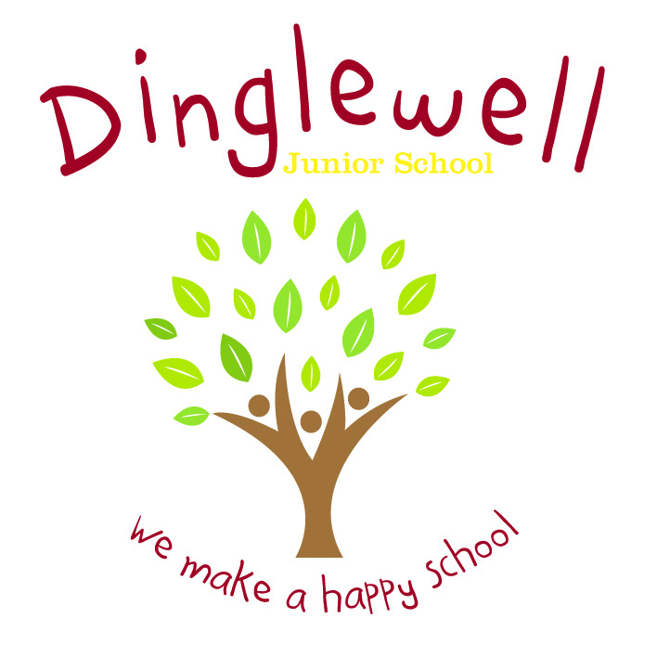**Subject: Religions & Worldviews Education**

**Impact: (What will the outcome look like and how will we find out)**

* Pupils can discuss their learning coherently using given vocabulary
* Pupils (and staff) feel able to articulate clearly and coherently their personal beliefs, ideas, values and experiences while respecting the rights of others to differ
* As children progress through the school, they develop a deepening knowledge, understanding and appreciation of religious and non-religious beliefs and practices so they can participate positively in our society in line with the Core British Values.
* Evidence is recorded accordingly and appropriately to the intended lesson outcome

**Implement: (How are we going to do it)**

* Teachers will plan a linear series of lessons which reflect on prior learning
* We use the Gloucestershire Agreed Syllabus for RE (2017-2022) as our primary source for planning
* Curriculum vocabulary is clearly listed on planning and modelled consistently by all staff to pupils during lesson time
* Elicit what pupils would like to know at the start of each unit and map out what they would like to learn
* The local area is utlilised for ‘outdoor learning’ opportunities to expand and develop pupils’ spirituality and sense of self.
* Use a range of primary and secondary resources and experiences to enhance pupils’ learning
* Maximise opportunities for R&WE in school e.g. discussion of current affairs (Newsround), multi-faith and non-religious assemblies etc
* Staff ensure the 3 strands of the Agreed Syllabus are embedded in planning – Making Sense of Beliefs, Understanding the Impact and Making Connections

Intent: **(What do we want our learners to know)**

Through our R&WE curriculum we aim to inspire our pupils to be curious about and question the world around them. Pupils are exposed to various religions and beliefs in local, national and global contexts; provoking challenging questions about meaning and purpose in life, beliefs about God, ultimate reality, issues of right and wrong and what it means to be human.

Through high quality teaching, planning and subject knowledge, we enable pupils to develop their own ideas, values and identities through the following:

* An expansive knowledge and understanding of religious vocabulary
* To recognise and describe core religious (and non-religious) beliefs, concepts and practices with progressive difficulty
* An understanding of the impact that beliefs and practices have on believers’ everyday lives, within communities and in the wider world
* To develop skills to evaluate, reflect on, challenge, question and connect beliefs and practices studied; discerning possible connections between these and pupils’ own lives and understanding of the wider world