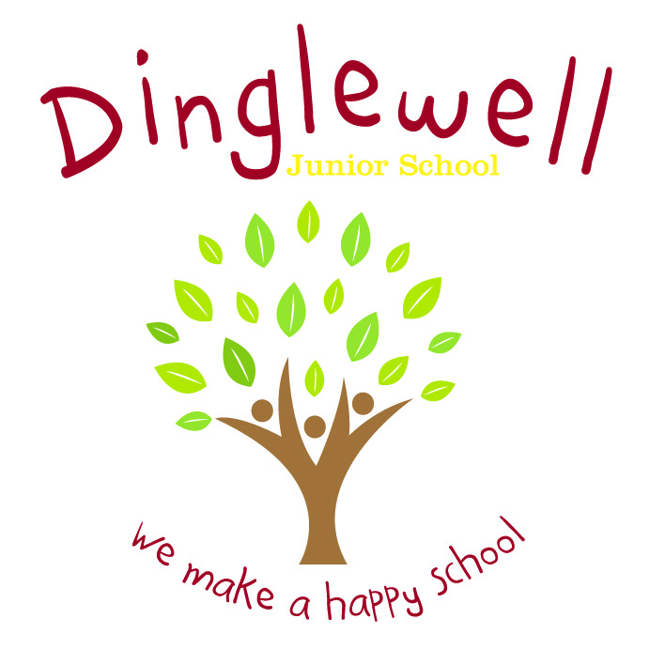**Subject: PSHE**

**Impact: (What will the outcome look like and how will we find out)**

* Children are able to understand and manage their emotions
* Children develop positive and healthy relationships with their peers, both now and in the future
* Children have positive self-esteem and respect for themselves and others
* Children are resilient and show perseverance
* Children are on their way to becoming healthy, open-minded, respectful and responsible members of society
* Children can problem solve and apply problem solving strategies to real-life situations
* Children appreciate difference and diversity

**Implement: (How are we going to do it)**

* We teach our PSHE using the Jigsaw PSHE approach. This means we teach our curriculum in six distinct topics or ‘puzzle pieces’ each year – Being Me in My World, Celebrating Differences, Healthy Me, Dreams and Goals, Relationships and Changing Me
* There is progression throughout the spiral curriculum and age appropriate key vocabulary is taught and built upon each year
* There are cross curricular links to the wider curriculum, such as computing (E-Safety), science (puberty) and PE (living healthy and active lives)
* Speaking and listening skills are developed through asking and answering questions and building upon others’ ideas
* Resilience is developed and nurtured through the teaching of emotional literacy
* Emphasis is placed on the importance of physical and mental health and children are equipped with the skills and strategies to develop in these areas

Intent: **(What do we want our learners to know)**

Our aim is for our children to leave Dinglewell Junior School with the knowledge, skills and emotional literacy to be able to play a positive, active and successful role in today’s diverse society.

We want our children to have confidence, high aspirations and self-esteem.

Our PSHE curriculum supports children in becoming healthy, independent and responsible citizens in their community

Our PSHE curriculum develops children’s ability to recognise their feelings and emotions

Our curriculum develops children’s confidence in tackling moral, social and cultural issues that they may experience in their lives

Our Children learn about their rights and responsibilities

Our children are encouraged to develop their sense of self-worth and self-esteem by contributing within the school community

Our curriculum is accessible and inclusive, meeting the needs of all of our pupils