**Subj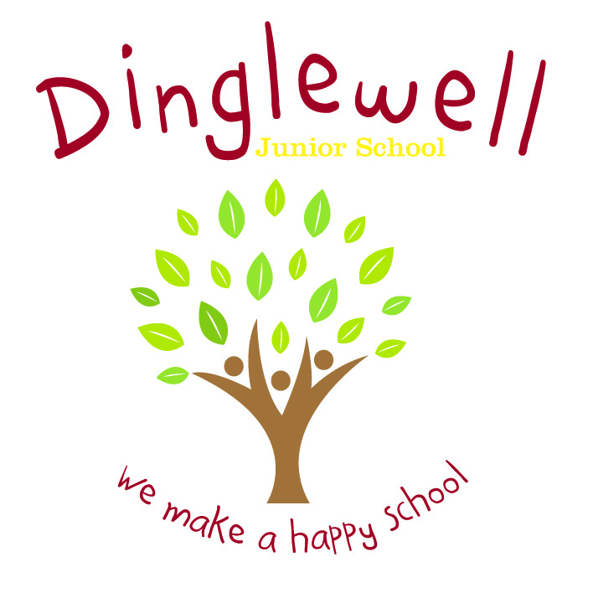ect: PE**

**Intent:** **(What do we want our learners to know)**

At Dinglewell Junior school, our PE curriculum is designed to develop creativity by engaging and inspiring all children with opportunities to develop their knowledge and skills in a safe and supportive environment. We want our pupils to develop and become proficient in the fundamental movements to ensure all children have good physical knowledge, skills and understanding to succeed to their personal potential.

Throughout their time at Dinglewell Junior School, our pupils will understand and take **ownership** of their **health** and **fitness**, **wellbeing** and **enjoyment** within sport.

**Implement: (How are we going to do it)**

Curriculum:

* We use the Get Set 4 PE scheme, which is a clear and comprehensive scheme of work which ensures each lesson has progressive activities that are designed to inspire and engage all our pupils, allowing them to explore and develop skills and embed knowledge.
* Lessons in each unit also show a progression of skills within and throughout each year group across the different strands of PE.
* Children will have a minimum of 2 PE lessons per week (normally 1 indoor and 1 outdoor) as well as a range of daily mile, go noodle and active blasts.
* Children will be provided with regular opportunities across the year to take part in intra-school competitions – cross-country, gymnastics, football, hockey, rugby, netball and more.
* Children in Year 3, 4, 5 and 6 have swimming lessons taught by specialist instructors at GL1 (Y6 due to COVID catch up)
* Wellbeing, health and fitness is also covered in a range of activities within the Get Set 4 PE scheme of work.

Pedagogy:

* Teachers are provided with a range of teaching points from the scheme lesson plans to help them to develop their subject knowledge and the ability to differentiate tasks to appropriately challenge all pupils.
* Teachers encourage children to develop their fitness, health, well-being and enjoyment by sharing appropriate subject knowledge, terminology as well as modelling skills.
* Teachers encourage the use of iPad’s themselves and by children to help the children to take ownership of their learning and develop their skills progression within lessons.
* Over the course of 22/23 subject leaders and teachers will implement the Get Set 4 PE assessment framework to track pupil progress and develop their own teaching.

External Provision:

* All classes and children have 2 terms of specialist Montagu Academy coaches who teach new technique and skills in line with the Get Set 4 PE scheme to the children whilst also providing the teachers with CPD.
* All children will be provided with an opportunity to take part in a range of outside after school club activities throughout the year.
* All children will have the opportunity to take part in a range of competitive sporting events, put on by the GSSN, against other schools.

**Impact: (What will the outcome look like and how will we find out)**

Pupils learn to take ownership and responsibility of their own well-being and fitness in order to live happy and healthy lives.

* **Health**: Children can explain and demonstrate how to keep themselves healthy, within lessons and through pupil voice questionnaires.
* **Fitness**: Children can demonstrate improving strength, stamina, skills and knowledge throughout the progression of lessons. Teachers will observe fitness development and use IPad’s to help further progression.
* **Wellbeing**: Children will have increased self-esteem, self-worth and confidence within PE lessons. Teachers will see positive attitudes from all children to all aspects of PE.
* **Ownership**: Children will take ownership of their skills and knowledge development through the use of IPad video evaluations, self and peer assessments.
* **Enjoyment**: Children and staff will be enthusiastic and motivated in PE lessons to work to their potential, wanting to demonstrate skills and knowledge, as well as joining after school clubs and participating in competitive sports.

By the end of each unit, pupils will make the expected progress by knowing, applying, understanding and explaining the skills and processes specified in the relevant unit from Get Set 4 PE.