**Subj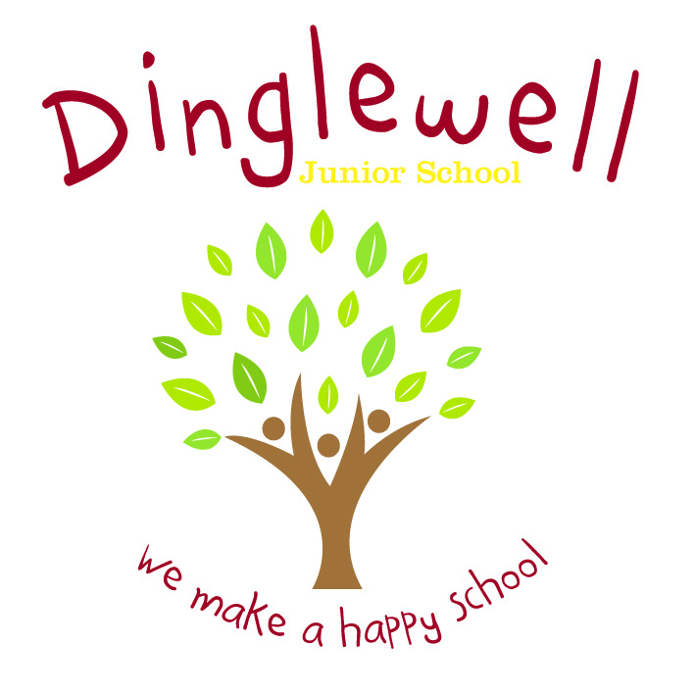ect: Music**

Intent: **(What we want our learners to know)**

Our music curriculum covers the statutory National Curriculum for England and is designed so as children gain a firm understanding of what music is through listening, singing, playing, evaluating, analysing, and composing across a wide variety of historical periods, styles, traditions, and musical genres, including the works of the great composers and musicians. We aim to develop a curiosity for the subject, as well as an understanding and acceptance of the validity and importance of many types of music, and an unbiased respect for the role that music may wish to be expressed in any person’s life.

Through high quality teaching, planning and subject knowledge, we continue to develop the following essential characteristics of a musician:

* Understand and explore how music is created, produced and communicated through the interrelated dimensions.
* The ability to play a musical instrument.
* Using an expansive knowledge of musical vocabulary when listening, performing, composing and evaluating music.
* Use and perform from musical notations.
* Identify a range of orchestral and percussion instruments.
* The ability to perform and compose using a range of pitched and unpitched percussion instruments, including the voice.
* Identify musical facts.
* The ability to listen to and evaluate a wide variety of music.

**Impact: (What the outcomes will look like)**

* As children progress through the school, they develop a deep knowledge, understanding and appreciation of historical periods, styles, traditions, cultures, and musical genres.
* By the end of each year children will have a bank of facts they will know.
* Pupils can discuss their learning coherently using musical vocabulary.
* Evidence of attainment in listening and appraising through use of music note books in each class.
* Pupils can perform and compose using a range of pitched and unpitched instruments, showing recognition of musical notation.

**Implement: (How we are going to do it)**

* Following on from children’s prior learning, teachers will use ‘Sparkyard’ as a means of delivering the curriculum to ensure progression throughout the school.
* In addition to classroom music lessons children have access to weekly singing assemblies, a Christmas Concert and Christingle Service, the learning of instruments, including iRock, and participating in Young Voices.
* Staff are supported through Staff meetings and planning time (PPA).
* The elements of music are displayed and referred to within the classroom.
* Musical vocabulary is identified on plans and relevant vocabulary displayed in the classroom.
* In year 6 students learn how to play the recorder and in year 4 students learn how to play the ukulele and in doing so embed their understanding of musical notation.
* Children build on skills and knowledge as they progress through Dinglewell Junior School, teachers being aware of facts and skills being taught in the year(s) prior to their teaching.
* Listening and appraising is woven through lessons and key pieces/composers are identified for each year group within our ‘Sparkyard’ music scheme.
* Trips and visitors enhance learning experiences e.g. visits to local secondary to watch performances.
* Each year group have a bank of facts they are to teach.