**Subject: 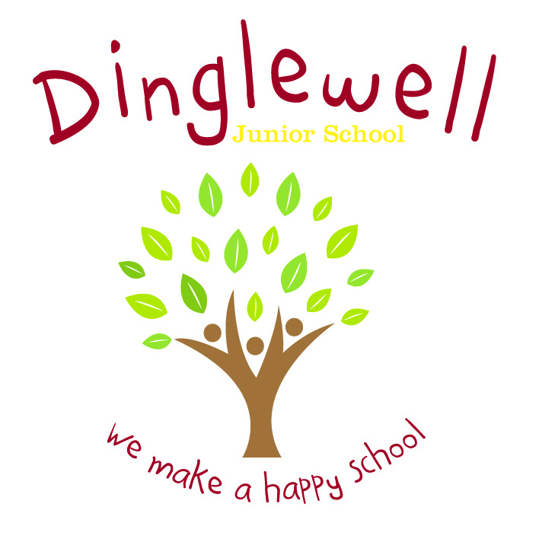History**

Intent: **(What do we want our learners to know)**

We aim for a high quality history curriculum which should inspire in pupils a curiosity and fascination about Britain’s past and that of the wider world.

Through high quality teaching, planning and subject knowledge, we develop the following essential characteristics of a historian:

* An understanding of chronological historical events.
* Develop skills in enquiry, analysis, evaluation and argument.
* An understanding of the impact that historical events had on modern life.
* Wide and varied use of vocabulary.

**Impact: (What will the outcome look like and how will we find out)**

* Pupils will be curious and motivated
* As historians, children will learn lessons from history to influence the decisions they make in their lives in the future
* Evidence is recorded accordingly and appropriately to the intended lesson
* Pupils can discuss their learning coherently using a given vocabulary.

**Implement: (How are we going to do it)**

* Teachers will plan a linear series of lessons which reflect on prior learning
* Elicit what pupils would like to know at the start of each unit and map out what they would like to learn
* Use a range of primary and secondary resources
* Use external companies, local museums, artefacts, etc.
* New history learning is put into the context of the big picture of history learning throughout the school and a review of previous learning.