**Subject: 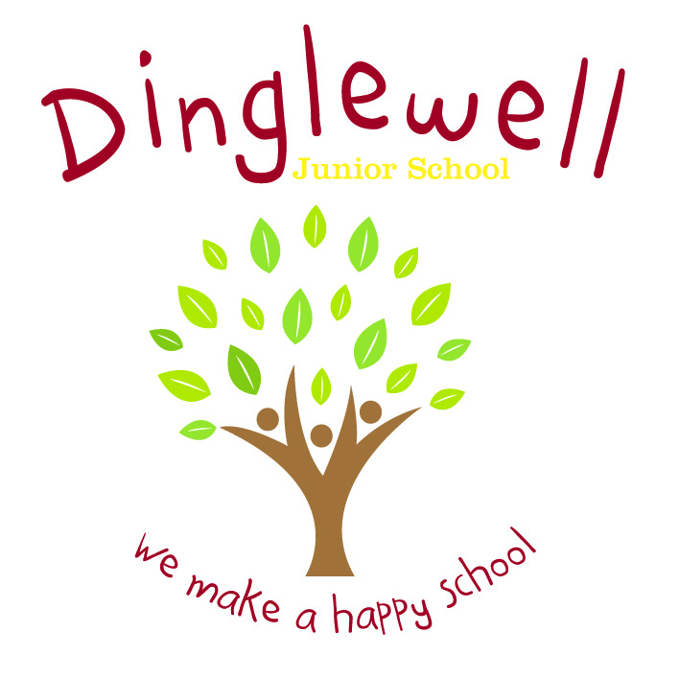Geography**

**Implement: (How are we going to do it)**

* Teachers will plan a linear series of lessons which reflect on prior learning
* Curriculum vocabulary is clearly listed on planning and modelled consistently by all staff to pupils during lesson time
* Elicit what pupils would like to know at the start of each unit and map out what they would like to learn
* The local area is used as ‘outdoor learning’ opportunities to expand on the pupils’ locational knowledge
* Trips and visitors will enhance their learning experience. Maximise the opportunities for Geography in school e.g Newsround, current affairs and school holidays.
* Staff are supported through the use of relevant resources and planning time (PPA)
* Staff ensure the 4 strands of the curriculum are embedded in planning - Locational Knowledge; Place Knowledge; Human and Physical Geography and Geographical Skills and Fieldwork

Intent: **(What do we want our learners to know)**

Our Geography curriculum is designed to inspire our pupils through thinking like a geographer. The pupils should be curious and question the world around them. Through a topic-based curriculum, pupils are exposed to various locations and geographical features both locally and throughout the world

Through high quality teaching, planning and subject knowledge, we develop the following essential characteristics of a geographer:

* An excellent knowledge of where places are both locally and in the wider world
* An expansive knowledge of geographical vocabulary and knowledge
* The ability to read and recognise features of maps with progressive difficulty
* To question the society of the world they live in and form balanced arguments through an understanding of subject knowledge and current relevant issues

**Impact: (What will the outcome look like and how will we find out)**

* Pupils can discuss their learning coherently using a given vocabulary for both the upper and lower key stage during relevant points in a topic
* Pupils can distinguish between history and geography with a growing enthusiasm for the subject because it is relevant to them
* As children progress through the school, they develop a deep knowledge, understanding and appreciation of their local area and its place within the wider geographical context
* Pupil voice (they can discuss their learning)
* Evidence is recorded accordingly and appropriately to the intended lesson outcome