**Subject: 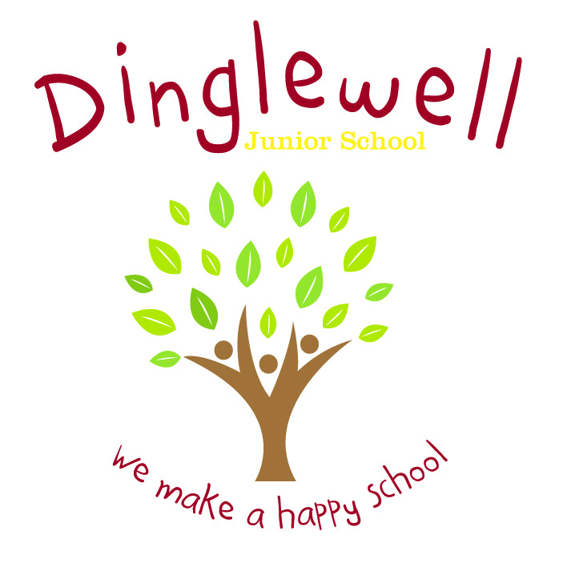French**

**Implement: (How are we going to do it)**

* Teachers will use the planning and resources provided by the Language Angels scheme to deliver lessons which build upon prior learning
* Staff are supported through the use of relevant resources and planning time (PPA)
* The school has a unit planner in place which will serve as an overall ‘teaching map’, outlining for all teachers within the school what each year group will be taught and when it will be taught
* Curriculum vocabulary is clearly listed on the teacher support notes and modelled consistently by all staff to pupils during lesson time
* Staff ensure the 4 language skills are embedded in each unit – listening, speaking, reading, writing
* Knowledge and awareness of required and appropriate grammar concepts will be taught throughout all units at all levels of challenge.

Intent: **(What do we want our learners to know)**

Our French curriculum is designed to inspire our pupils to develop an interest and positive curiosity about foreign languages. Learning a second language will offer pupils the opportunity to develop a deeper understanding of other cultures and the world around them with a better awareness of self, others and cultural differences. We intend to offer a relevant, broad, vibrant, and ambitious foreign languages curriculum that will inspire and excite our pupils using a wide variety of topics and themes.

Through high quality teaching, planning, and subject knowledge, we develop the following essential characteristics:

* The ability to listen, speak, read, and write in the target language with progressive difficulty
* An expansive knowledge of French vocabulary
* An understanding of key French grammar
* An understanding of key French phonics.

**Impact: (What will the outcome look like and how will we find out)**

* Pupils can discuss their learning coherently using given vocabulary
* As children progress through the school, they develop a deep knowledge, understanding and appreciation of other languages and cultures
* Pupil voice (they can discuss their learning)
* Evidence is recorded accordingly and appropriately to the intended lesson outcome