**Subject: 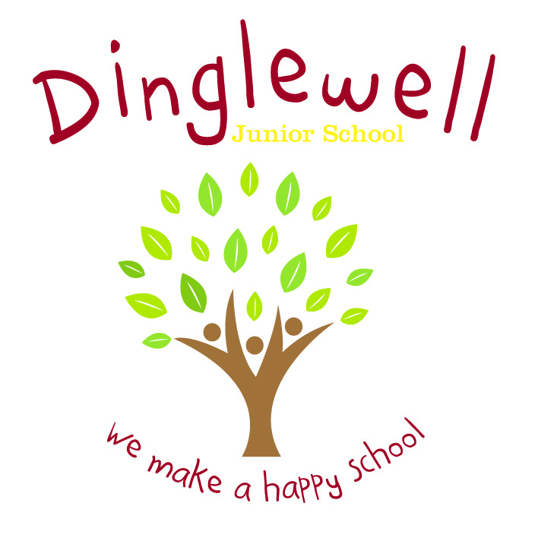Design Technology**

Intent: **(What do we want our learners to know)**

Our DT curriculum is designed to inspire our pupils through thinking like an innovator. The pupils should be analytic and question existing products in the world around them.

Through high quality teaching, planning and subject knowledge, we develop the following essential characteristics of an innovator:

* Creative, technical and imaginative thinking in children and to develop confidence to participate successfully in an increasingly technological world.
* The ability to talk about how things work and to develop their technical knowledge,
* The ability to select appropriate tools and techniques when making a product, whilst following safe procedures,
* An understanding of technological processes and products, their manufacture and their contribution to our society,
* Enjoyment, satisfaction and purpose in designing and making things,
* The ability to critique, evaluate and test their ideas and products, and the work of others,
* Understand and apply the principles of nutrition and to learn how to cook,
* Understand how key events and individuals in design and technology have helped shape the world.

**Implement: (How are we going to do it)**

* Teachers will plan a linear series of lessons which reflect on prior learning
* Curriculum vocabulary is clearly listed on planning and modelled consistently by all staff to pupils during lesson time
* Elicit what pupils would like to know at the start of each unit and map out what they would like to learn
* Trips and visitors will enhance their learning experience – visit food establishments; links with local senior schools to use their equipment/facilities
* Staff are supported through the use of relevant resources and planning time (PPA)
* Staff ensure they use the ‘Projects on Page’ resources for continued progression throughout the Key Stage

**Impact: (What will the outcome look like and how will we find out)**

* Pupils can discuss their learning coherently using a given vocabulary for both the upper and lower key stage during relevant points in a topic
* As children progress through the school, they develop a deep knowledge and understanding of the skills required in product innovation: design and evaluation alongside the technical skills
* Pupil voice (they can discuss their learning)
* Evidence is recorded accordingly and appropriately to the intended lesson outcome
* Pupils become creative problem-solvers, both individually and as part of a team