**Subject: 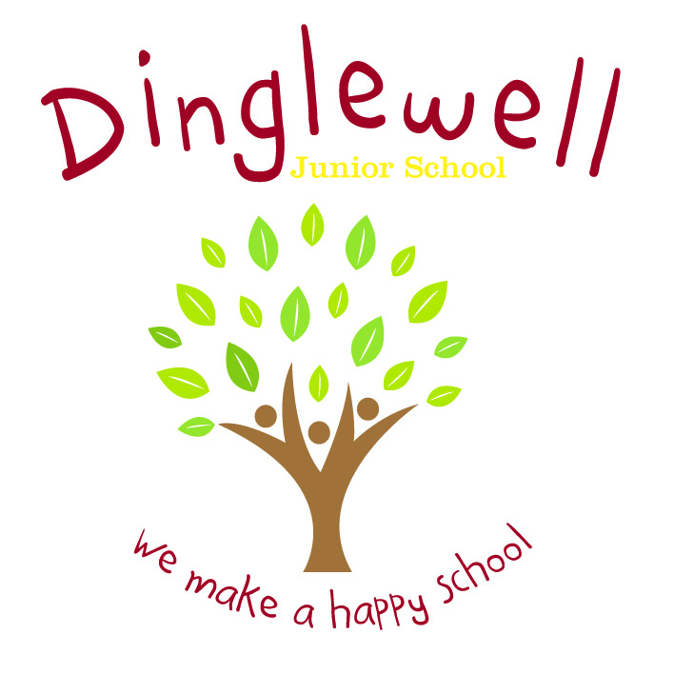Computing**

**Impact: (What will the outcome look like and how will we find out)**

* Pupils can discuss their learning coherently using Computing-specific vocabulary.
* Pupils will be able to discuss links between different elements of Computing: e.g. multimedia and network; data and communication.
* As children progress through the school, they develop a deep knowledge, understanding and appreciation of Computing and how it can be used effectively.
* Pupil voice (they can discuss their learning).

Intent: **(What do we want our learners to know)**

Our Computing curriculum is designed to deliver a coherent, broad and well-balanced education which is knowledge-rich and develops each learner’s cultural, as well as technological capital.

Through high quality teaching, planning and subject knowledge, we develop the following essential characteristics:

* An excellent knowledge of Computing across the 5 strands of the NC.
* An expansive knowledge of Computing vocabulary which shows coherent progression through the KS.
* The ability to confidently use a range of hardware and software.
* Resilient learners through giving children the opportunity to solve problems, de-bug and make things work.

**Implement: (How are we going to do it)**

* Spiral implementation of the 5 key strands of Computing between the four Junior year groups of the key stage: skills are repeated but always in greater detail and with enhanced knowledge and capacity for learners to extend their Computing skills.
* Curriculum vocabulary is clearly listed on planning and modelled consistently by all staff to pupils during lesson time.
* Teachers are aware of how technology is used by children at home and works alongside/builds upon such development.
* Staff are supported through the use of relevant resources and planning time (PPA).
* Staff ensure the 5 strands of the curriculum are embedded in planning: Programming, Data, Communication, Digital Literacy & Research and Multimedia; and Programming.