Year 5 Autumn Terms 1 and 2 – 2023: THE SECRET OF SUTTON HOO - HOMEWORK
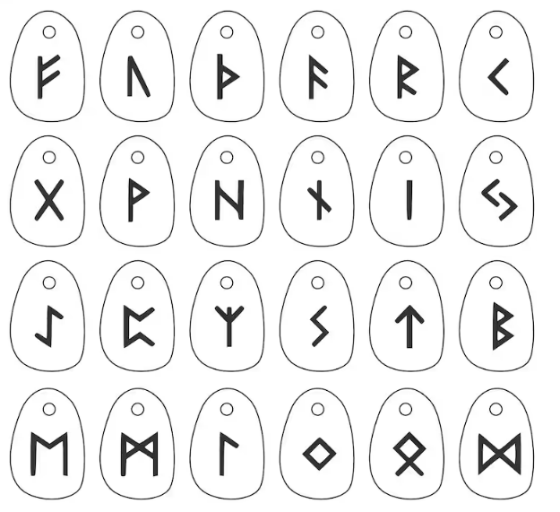  Make a set of runes by decorating small stones. | Create a time line of events in Anglo Saxon times. | The Early Settlers & Invaders loved knots. Use string to create as many different knots as you can. How will you choose to present these? In a booklet? As a display? Poster? Maybe you could write the instructions for these. | Use your knowledge of dissolving and evaporation to grow your own sugar crystals and create an editable science experiment. Just follow these instructions.  https://www.science-sparks.com/how-to-grow-sugar-crystals/
Make fizzing bath bombs by mixing an acid and an alkali – follow the instructions from the Royal Society of Chemistry. https://edu.rsc.org/primary-science/making-bath-bombs/4011691.article | Design a Viking board game. How many players can play? What is the purpose of the game and how do you win? | 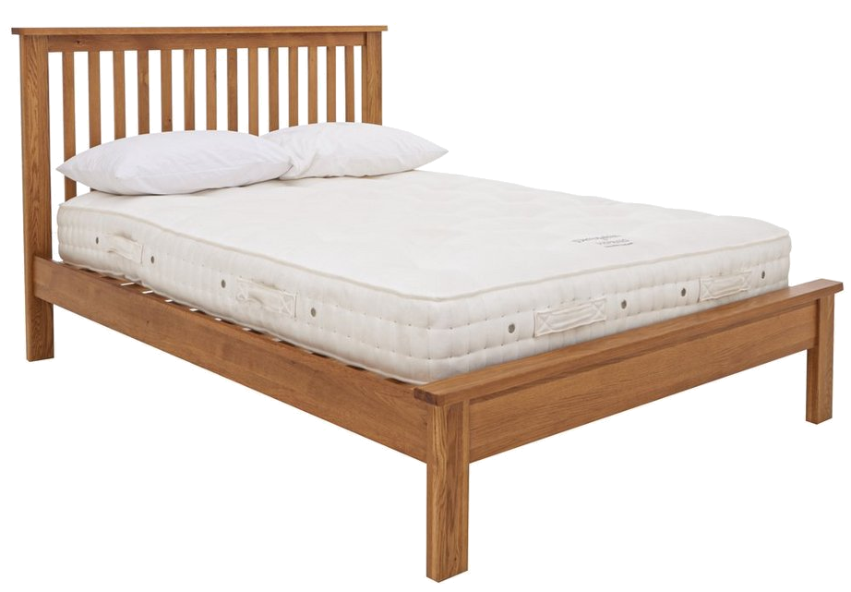  How many different materials were used to create your bedroom? Can you draw a labelled diagram showing where the different materials have been used and why they are suited for that particular purpose. For example: wooden bed frame – strong, sturdy and rigid. | Research French Christmas traditions. How will you choose to present your findings? As a Power point presentation? In a booklet? As a display? Poster?
Write a factual report about what the Anglo-Saxons wore. | Use a map and see how many Anglo Saxon place names you can find. If they end in – ton, -ham, -burgh what did it mean? Can you find out anything else about the names of towns and villages in our country? | Do some research on beetles, you could make a poster to show what you have learnt. | Legend has it that while Alfred the Great was on the run from the Vikings, he took refuge in a peasant women’s home. She asked to watch the cakes she was baking but he was distracted and they burnt! What kind of cakes do you think she was baking? Can you bake some or write a recipe for them?
Draw/paint/make a model of an Anglo-Saxon/Viking house. | 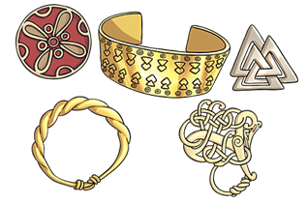  Research and design a piece of Viking jewellery. What is it made from? Why did you choose your design? What inspired you? | Create a replica of an Anglo-Saxon helmet. | Research the weapons and armour that were used by the Vikings. Invent your own weapon similar to those being used. You could write an advert to describe the weapon. Include pictures and details about why the Viking should buy it.
Write some noun, who/which/where sentences about Anglo Saxon or Viking gods ensuring that you use commas correctly. | Use your spelling words to write sentences – make sure you know what they mean.  Challenge: Make it into a quiz! | Write a short diary of what you did during the week or weekend; ensure you use a range of fronted adverbials. | Find out about the Bayeaux Tapestry and write a fact file or short report about it.  http://www.primaryhomeworkhelp.co.uk/bt/tapestry.htm
Create a Power point about Sutton Hoo. | Find out about the Anglo-Saxon or Viking gods. How could you present your information? | Create a factsheet/film about a subject of your choice. You could use I movie or movie maker. | Write a poem linked to colours and practise performing it.

The homework tasks are not mandatory: you and your child might choose which tasks you think your child would most benefit from completing. Please, by all means make them mandatory for your child.
All homework needs to be uploaded to TEAMS through assignments. Each week the assignment will show on TEAMS so that new work can be uploaded. Please send a paper copy in if you are unable to upload work to TEAMS.
Please let us know if you need to be re-issued with a TEAMS log-in, they are the same as last year’s.

Thank you.
Year 5 Team

